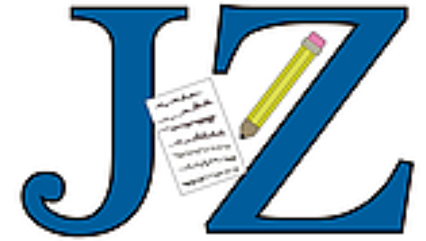**­­­Jake Ziegler**

[jakeziegler.com](https://www.jakeziegler.com/) | **(603) 339-6976**| **jacob.ziegler18@yahoo.com** |

# Experience

# Sports Editor | Mohave Valley Daily News | Bullhead City, AZ | Oct. 2021 – Nov. 2021

# Covered local high school sports for five different schools

# Wrote articles and built/designed newspaper pages for publication’s sports section

# On-Air Talent / Multimedia Producer | New Media Broadcasters, Inc. | Havre, MT | July 2021 – Sept. 2021

# Recorded voiceovers for local newscasts and sportscasts for KOJM, KPQX, & KRYK

# Produced and edited other audio content, such as weather updates, road reports, and event promotions

# Board operated KOJM & KPQX for live sports broadcasts

**Radio Show Host | WQAQ 98.1 FM | Hamden, CT | Sept. 2016 – May 2021**

* Conducted a weekly, one-hour, live NFL talk show on Quinnipiac’s student-run radio station
* Hosted a rock music radio show that features mine and my co-host’s favorite classic / modern rock hits

**Camera Operator | Quinnipiac Athletics | Hamden, CT | Dec. 2017 – Feb. 2021**

* Shot live hockey and basketball footage for games that aired on *ESPN3* & *ESPN+*
* Communicated efficiently with the control room to make production quality adjustments

**Hockey Play-by-Play Broadcaster | CT RoughRiders | Norwalk, CT | Sept. 2019 – Nov. 2020**

* Commentated junior hockey team’s home games through *HockeyTV* platform
* Prepared extensive game preparation for broadcasts through researching facts and statistics

**Sports Reporter / Commentator | Quinnipiac Bobcats Sports Network | Hamden, CT | Sept. 2016 – April 2020**

* Broadcast Quinnipiac sporting events, including play-by-play and color commentary
* Composed and published game recaps and an athlete feature for QBSN’s online publication
* Disseminated live, in-game updates on QBSN’s Twitter account as a multimedia producer
* Awarded as the writer of the year (2016-2017) for demonstrating consistency and improvement in overall writing skills and for publishing several game recaps and an athlete feature

# Skills

Microsoft Office, Adobe Premiere, iMovie, Adobe Audition, Audacity, Adobe InDesign, ENPS

# Education

Quinnipiac University, Hamden, Connecticut

Master of Science in Sports Journalism – Graduation Date: May 9, 2021 - Cumulative GPA: 3.7

Bachelor of Arts in Journalism | Minor: Sports Studies – Graduation Date: May 16, 2020 -

Cumulative GPA: 3.72 | Magna Cum Laude | Dean’s List Appearance Eight Consecutive Semesters

*\*References available upon request\**