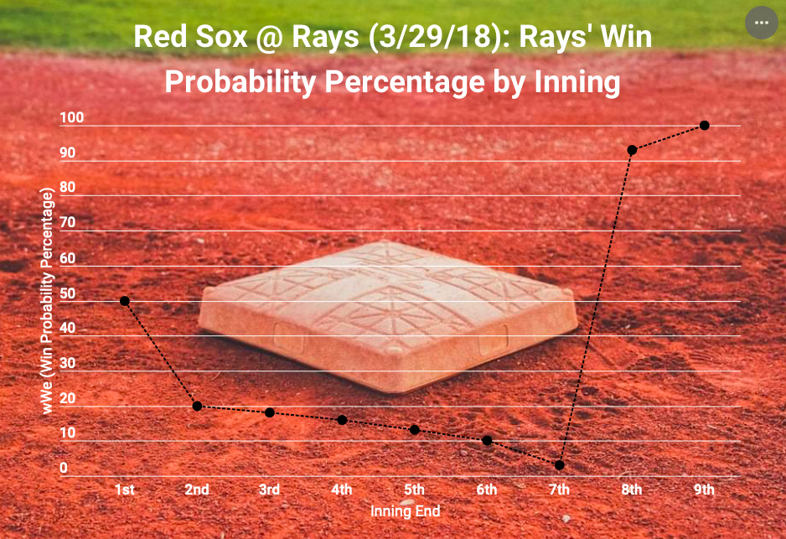

This data visualization graphic represents Tampa Bay's winning percentage probability inning-by-inning throughout their 2018 home-opener against the Boston Red Sox on March 29, 2018. As you can see, the Rays understandably begin the game with a 50% chance of winning, as any team would to start any given game. However, the chances of winning this game gradually decreased from the 1st to the 7th inning's end, as the Red Sox tallied some runs throughout those innings. Boston established a 3-0 lead at the 2nd inning's conclusion, in addition to a 4-0 lead after the 7th inning.

The turning point for the Rays arrived in bottom of the 8th inning when they registered 6 RBIs courtesy of a double, walk with the bases loaded, triple, and single from Tampa's clutch batting performance. As such, the Rays gained a 6-4 lead, causing their win probability percentage to drastically jump from 3% at the end of the 7th inning to 93 % after the 8th inning. Tampa was able to hold on for the 6-4 victory after its pitcher closed the deal with notching a lineout and 2 groundouts after 4 batters. Overall, it's safe to conclude that based on the graphic, Boston blew a 4-0 lead after having a high probability percentage throughout the game, while Tampa Bay had a small chance to comeback, yet ultimately won their 2018 home-opener in rally fashion.

*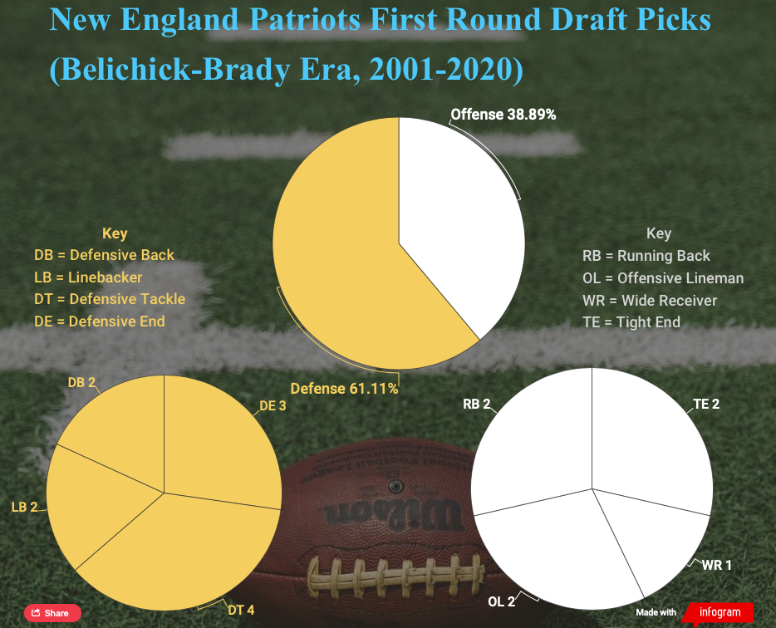*

*This data visualization graphic represents the first-round draft picks selected by the New England Patriots during the Brady-Belichick era, from 2001 to present day. The data is sorted into three different pie charts: one with the percentage comparison between offensive and defensive selections, another that breaks down how many selections from each applicable defensive position were taken, and the other displaying how many selections from each applicable offensive position were taken.*

*This graphic shows that throughout the 21st century, Bill Belichick and the New England Patriots have primarily selected defensive positions in the first round for his roster since taking over the franchise in 2001. More specifically, the future Hall of Fame coach has focused on his defense's front seven players as opposed to the secondary in the first rounds of most drafts, since LB, DT and DE account for 9 of the 11 defensive player selections. This should come as no surprise for anyone who knows Belichick because his specialty in coaching the sport lies on the defensive side of the ball. On the flip side, Belichick has selected an even number of players from all offensive positions in the first round, with the exception of QB, which is obviously understandable, considering the unprecedented success of Tom Brady.*

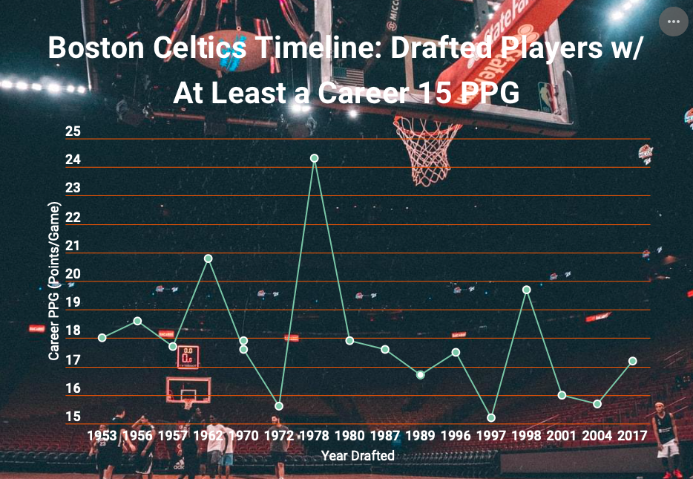

*This data visualization graphic represents the Boston Celtics' draft history as it relates to former or current players who have a minimum of 15 points scored per game (PPG) in their professional career. Each data point includes the player's name, draft year, as well as their career PPG. As shown by the data, Larry Bird ranks the highest with 24.3 PPG, and there's no pattern or trend in this statistical category over the franchise's draft history, as the data points are scattered all over the line graph. The overall story's message is that the Boston Celtics have been drafting solid scorers since its establishment, as there are 18 players who have scored at least 15 PPG from 1953 to 2017, while Jayson Tatum is still balling for them.*

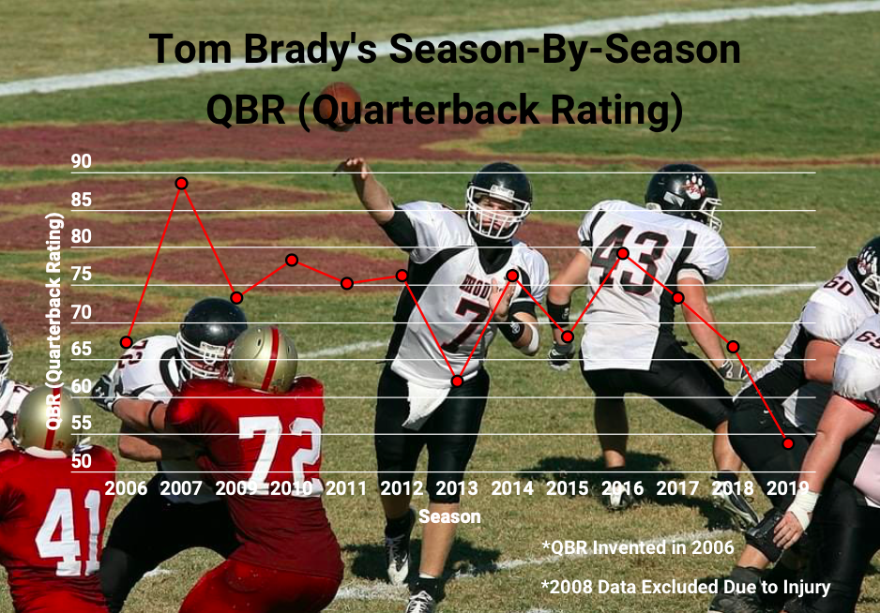

*This graphic represents Tom Brady's QBR (Quarterback Rating) for each season from 2006 to present. His 2008 data was excluded because of his season-ending knee injury sustained very early during that year. Invented by ESPN in 2006, QBR measures events like incompletion type, quarterback rush type, and how far each pass travels in the air in effort to better evaluate a quarterback's performance. Brady's best QBR was in 2007 with an 88.5, and his worst was most recently in 2019 with a 53.7.*

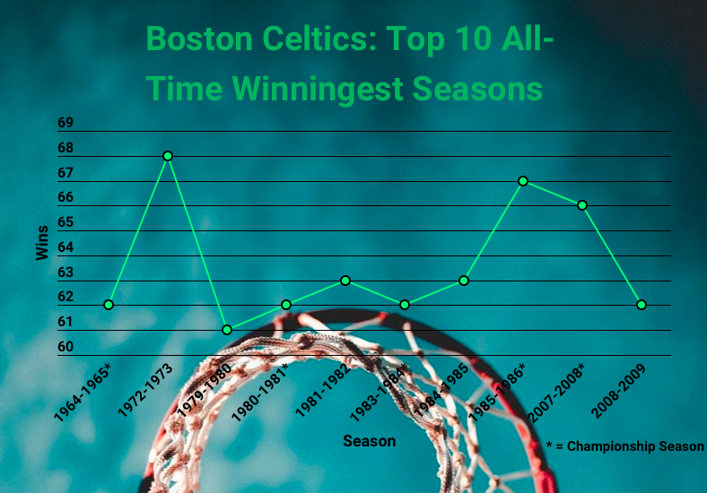

*This graphic represents the Boston Celtics' top 10 all-time winningest seasons in franchise history. Five of these 10 seasons have resulted in championship victories, including '64-65, '80-81, '83-84, '85-86, and '07-08. It's worth noting that their '80-81 season only contained 80 games, as opposed to the standard 82. The Celtics' '72-73 season is currently their best with 68 wins; however, that squad fell short of a title.*

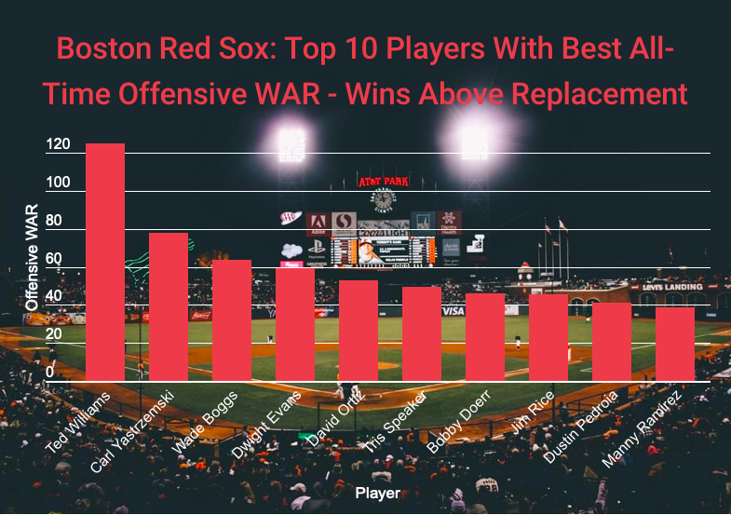

*This graphic represents the top 10 Boston Red Sox players who have the highest all-time WAR (Wins Above Replacement). WAR takes hitting, base-running, fielding and pitching into consideration to calculate how many wins a player was worth compared to a replacement player. Ted Williams has the highest WAR by far at 125.1, while the remaining players rank far behind such.*

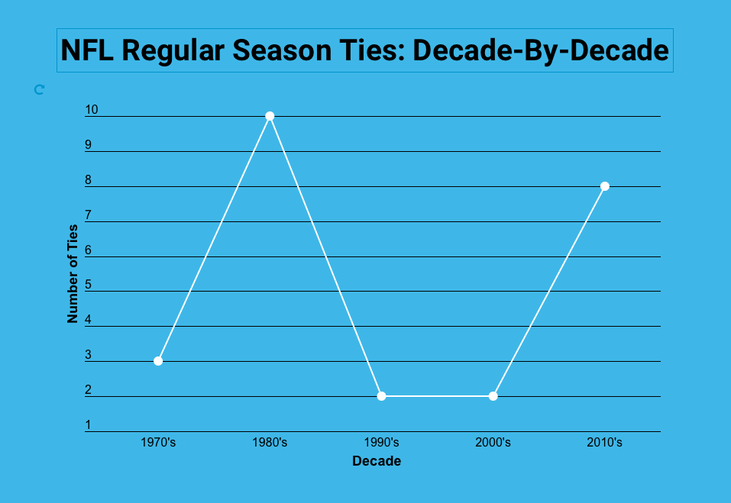

*This graphic represents a visual timeline of how many NFL regular season gamed ended in ties during each decade from 1974 to 2019, with the 1980’s containing the most at 10.*

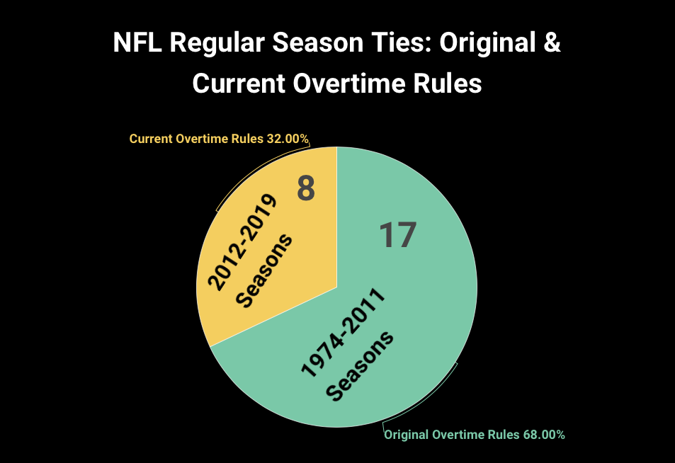

*This graphic represents how many NFL regular season draws transpired during both the original (1974-2011) and current (2012-Present) overtime rule eras.*

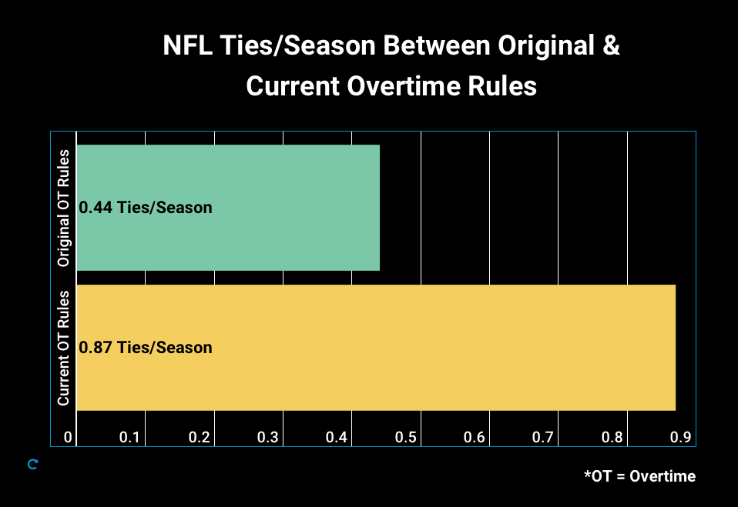

*This graphic represents how many NFL ties per season occurred in comparison between the original overtime rules (1974-2011) and current overtime rules (2012-Present).*

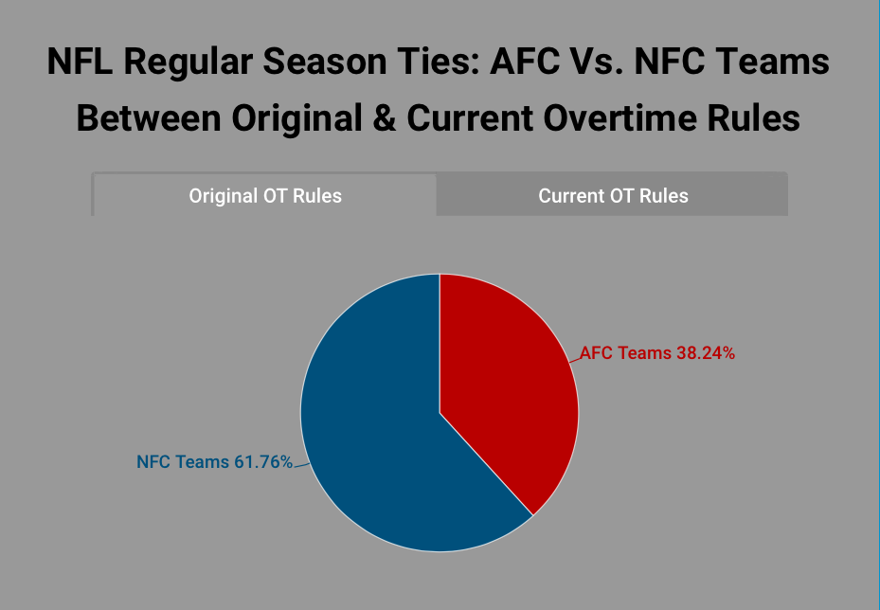

*This graphic represents the proportion comparison between AFC and NFC teams that participated in NFL ties during the enforcement of the original overtime rules (1974 - 2011).*

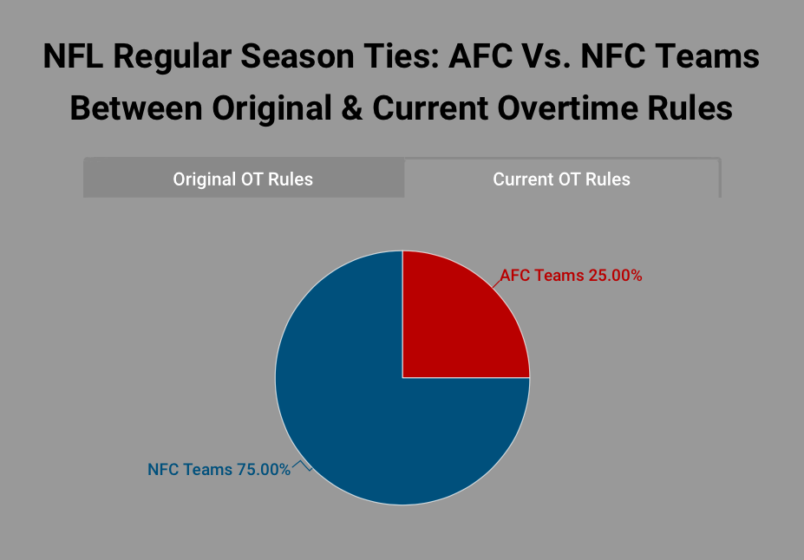

*This graphic represents the proportion comparison between AFC and NFC teams that participated in NFL ties during the enforcement of the current overtime rules (2012 - Present).*